Animation With Loops

Animation is the produced by repeatedly displaying an image to the screen, making a slight change each time. This is ideal for a while loop.

# How to Make Something Move

* + Select a position parameter (x or y or both).
  + Then have the loop count up or down (depending on direction of movement)
  + In the body of the loop, cear the screen and draw the shape, then sleep for a few milliseconds, before looping back.

**Java Syntax**

x = 0; **// Initialize**

while (x < 100) { **// Test**

synchronized(c) { **// Act**

c.clear();

c.fillRect(x, 50, 10, 10);

}

Thread.sleep(10);

x= x + 1; **// Change**

} **// Loop**

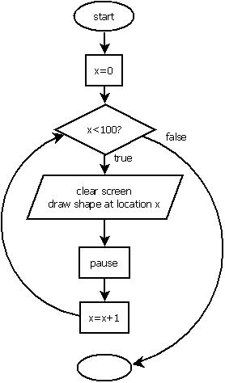

# Synchronization

In the code above, there is a new structure. When you draw to the screen you should try and collect all drawing statements (any statement that makes a change to the screen) together in one place and wrap them in a “synchronized(c) { }” block as shown above.

If you do not do this, your code will still work, but you might notice some flickering. This happens because the console only refreshes the view 60 times per second and this process is running independently of your program. If it happens to refresh after you have cleared the screen but before you draw the new shapes, or if it refreshes while you are drawing shapes, you will see flickering. The “synchronized” statement makes sure that your drawing will not happen at the same time as the console is refreshing itself.

# Other Kinds of Animation

The basic idea of animation is to clear and redraw (inside a synchronization block) repeatedly. There are lots of effects you can create this way other than basic sliding movements as shown above. Here are a couple more ideas:

## Shape Shifting

* + Select a size parameter (height or width or both).
  + Then have the loop count up or down (depending on whether you are getting bigger or smaller)
  + In the body of the loop, clear and redraw the shape with the new size, then sleep for a few milliseconds.

## Fade in or Out

* + Select a starting color using red, green, and blue values.
  + Use a loop to change the red, green, and/or blue values of the color.
  + In the body of the loop, set the color, and redraw the shape.

